
Bilkent University

Object Oriented Software Engineering Project
Project short-name: Mr.&Mrs. Pac-Man Ext.
Design Report
Ecem İLGÜN, Aziz Osman KOZHAN, Başak Şevval EKİCİ, Talha ŞEKER
Supervisor: Bora Güngören

Progress Report
Oct 21, 2017
This report is submitted to the Department of Computer Engineering of Bilkent University in partial fulfillment of the requirements of the Object Oriented Software Engineering Project course CS319.
Contents
1. Introduction 1
1.1 Purpose of the System 2
1.2 Design Goals 2
1.2.1 End User Criteria 2
1.2.2 Maintenance Criteria 2
1.2.3 Trade-offs 2
2. Software Architecture 1
2.1 Subsystem Decomposition 2
2.2 Hardware/Software Mapping 2
2.3 Persistent Data Management 3
2.4 Access Control and Security 4
2.5 Boundary Conditions 7
3. Subsystem Services 1
3.1 GUI Layer 19
3.2 Game Logic Layer 20
3.3 Data Layer 20
4. Low Level Design 1
4.1 Object Design Trade-offs 2
4.2 Final Object Design 2
4.3 Packages 3
4.3.1 User Interface Package 19
4.3.2 Game Logic Package 20
4.3.3 Data Package 20
4.4 Class Interfaces 4

1. Introduction
1.1 Purpose of the System
Mr.&Mrs. Pac-Man Extended is 2D arcade game which is based on classical Pac-Man game. Therefore, the main purpose of the game is to eat all food on the map without colliding with ghosts. In addition to that, our game has new features such as new food, shield option and creating your own map. By these new features, interest of players will be sustained. This system will be constructed by considering object-oriented design techniques
1.2 Design Goals
The main purpose of a game is to entertain player(s). To do that, throughout the project, we have to focus on details which do not directly have an effect on the system. Moreover, with the help of object-oriented design, we aim making a project which is easy to extend. This part details the design goals of the system such as end user criteria, maintenance criteria, performance criteria and trade-offs.
1.2.1 End User Criteria
Usability: From user’s perspective, a game should be easy to use and learn. To provide this, we do not change commonly used keyboard buttons to move Pac-Mans. First user plays with arrows and other one plays with W, A, S, D combination. Additionally, the purpose is to avoid confusing GUI design; therefore, GUI will have simple design. On the main menu, there is help section to adapt user to new features. User can realize what to do with suitable icons and prompts. Shield, pause and help panel will appear as pop-up for simplicity. Therefore, user does not have to pass windows each time.
Performance: For a good game experience, we try to overcome input lags and low fps. For example, user can hit a ghost due to keyboard input lag and this is frustrating. To achieve this, we focus on writing code as efficient as possible. The game is chosen to be applied in a 2 dimensional world not to experience rendering problems.

1.2.2 Maintenance Criteria
Extensibility: The game is designed in a way that allows developers to add new features and components to meet the user expectations. If deemed necessary, new shields, food or ghosts can be added. For now, two players can play the game locally; however, in the future, number of players can be incremented. All of these are beneficial for player experience.

Modifiability: The system designed will be centered around a multi layered architecture.
We have chosen three-tier architecture: Presentation tier includes user interface parts, logic tier makes logical decisions and calculations, and data tier stores and fetches data. Adapting three-tier architecture model allows us to modify each subsystem easily, without affecting any of the remaining ones.
Reusability: Subsystems can be used in other games or similar systems because the system is designed adhering to multitier architecture. Therefore, subsystems can carry out their functionality with other subsystems.
Portability: We have chosen to implement the game in Java. Java provides Java Virtual Machine (JVM) which is runnable in many operating systems. This feature of Java increases portability of the game.

1.2.3 Trade-Offs
Portability – Performance & Memory: In this project, we will use Java programming language which is runnable in many operating systems. This decision results in increased portability of the game.
However, it also means that Java will first compile the program into byte code and then has to call its interpreter, Java Virtual Machine, to interpret the code into machine code. Including this middle process in machine code generation, namely using JVM, may incur in performance penalty.
A second trade-off occurs in memory usage. Java's object model requires a lot more space. For instance, it makes use of wrapper classes for some of the basic types in C++ (e.g. int vs Integer wrapper class). These wrapper classes carry the overhead of an Object class. Therefore, Java uses more resources and makes less function with more code compared to C++.
Functionality – Usability: At first glance, new features decrease usability. With each new feature, user encounters something different from the basic Pac-Man game and getting used to new features takes time. Therefore, since we have aimed to decrease orientation time of a new user, there will not be too much functionality which might cause confusion. However, the game might be quite boring without new features. This made us to add the new features mentioned in 'Purpose of the System'.
As a result, our purpose was to reach a middle ground between functionality and usability. We have added new features to increase functionality, but have refrained from making the game logic or the UI too complicated for the user to play/get used to.
Reusability – Performance: Multitier architecture will be followed to increase reusability of the system and its components. However, this design increases function calls; therefore, our choice of architecture will have a negative effect on overall performance.

2. Software Architecture
In this part, we will examine composition of our system. As it has been mentioned before, the system will be constructed by smaller subsystems. In this way, we can prevent huge chunk of codes and codes can be ordered systematically. In our project, we will use Model View Controller (MVC) design which is suitable for this kind of game project.

2.1 Subsystem Decomposition
In this section, we will demonstrate subsystems roughly. Detailed information about subsystems is in third chapter. While deciding subsystems, we aim loosely coupling each system and followed three-tier architectural style. Throughout the project, some code blocks will need to be changed; therefore, we do not couple subsystems strictly. Otherwise, all subsystems are affected due to a change in one subsystem. Additionally, such a design is beneficial to develop the game in the future. Briefly main concerns are modifiability and extensibility. Our system consists of three subsystems: GUI Layer, Game Logic Layer and Data Layer
- GUI Layer will have classes which is responsible for providing user interface and having interaction with user.
- Game Logic Layer will carry out all decisions and calculations.
- Data Layer will be responsible for protecting data about high scores and maps.
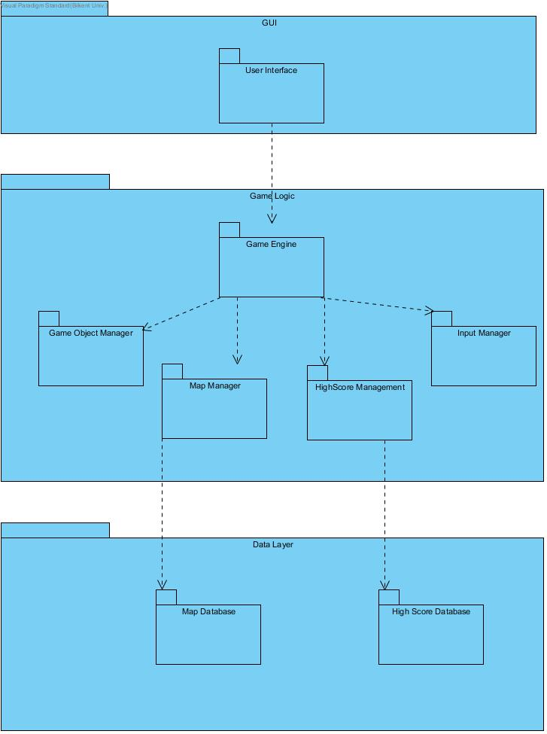
2.2 Hardware/Software Mapping
Our game will be implemented by using Java programming language. All user interface and graphics components will be constructed by using Java libraries. Most computers can run this game because it does not contain any 3D rendering and intense calculations. Our game requires a bit of memory because in data tier layer the system will make some operations such as saving high scores, map and game. To give inputs, basic mouse and keyboard will be enough. Due to these simple hardware and software requirements, this game is runnable in many computers and in many operating systems such as Windows, Linux and mac.
2.3 Persistent Data Management
In our game high scores, created map and current position of a game level are persistent identity that needs to be stored after each game. We will use local database for all of them because our game will not have any network connection. It means that user can only see high scores which obtained his/her own computer. By using file system, data will be written into txt. files.
2.4 Access Control and Security
Our game does not require any authentication or account because all data stored locally and do not require any private information from user. Therefore, the project does not require any access control or security.
2.5 Boundary Conditions
Execution
Mr.&Mrs. Pac-Man will be launched by double clicking .jar file of the game. The game does not need any special software other than Java Runtime Environment.
Termination
Scenario 1: Player clicks exit button on the pause menu.
Scenario 2: The game can be terminated by using Alt+f4 combination or clicking X icon on the window (for Windows).
Failure
Scenario 1: If there is an error with database system, a prompt will be appeared and user will not be able to save what s/he wants to save.
Scenario 2: If electricity or computer problem happen, the game will not give any opportunity to save the last situation. The user will lose all progress.

3. Subsystem Services
In this section, there are detailed expressions of subsystems.
3.1 GUI Layer
GUI Layer contains all user interface components. These components will be contained in user interface package. In this package, there will be main menu screen, help screen, pause menu screen, high scores screen, create map screen, game over screen, game screen, shield panel and name request screen.
If user clicks play game, game screen will be activated and GUI Layer and Logic Layer will communicate with each other to carry out logic. If first or second level is achieved, shield panel will appear as pop-up and again these two layers interact. If user saves a map, Logic Layer interacts with Data Layer to store the map.
3.2 Game Logic Layer
//SOME TEXT HERE
3.3 Data Layer
Data Layer contains high scores database, map database and current game database. Map database saves created maps and names. High scores database saves high scores and names. Current game database saves last situation of a saved game.

//CHAPTER 4 SPACE DESPOT DESIGN REPORT PART2’DEN BAKILABİLİR. BAŞLIKLAR ONA GÖRE AYARLANDI.
4. Low Level Design
4.1 Object Design Trade-Offs
4.2 Final Object Design
4.3 Packages
4.3.1 User Interface Package
4.3.2 Game Logic Package
4.3.3 Data Package
4.4 Class Interfaces

